Datastructures in Javascript
What are Datastructures?
They organize data efficiently, so that you can Store, Update, Delete & Find data quickly.
Datatypes vs Datastructure
Datatypes | Datastructure
In Javascript datatypes refers to the type of data a variable can store, Javascript has primitive datatypes and object types | Collection of different data in a container, it can functionalities to manage the data like find, delete, store, update

Datatypes are of two types
- Primitive types : string, number, boolean
- Non-Primitive types (Object types): object, arrays
Datastructure: They maintain the data in a container, Javascript has built-in datastructure which you can use and perform various operations
- Array: collection of values of same/different types
- Object: it will have properties and functions
- Set: A type of array that can store only unique elements, it doesn’t allow duplicates
- Map: A collection that maintain the data in key & value pairs, ex: maintain database details {username : admin, password : admin123}
Datastructure normally comes with two types
- Linear datastructure: arrays, linked list, stack, queue
- Non-Linear datastructure: trees, graphs
Algorithms: These are step by step instructions written in a human understandable language before writing the actual code, then you can implement them in different languages like Java, Javascript, C, C++
Advantage of using algorithms is
It tells you the time complexity & space complexity of the programs
Time complexity & Space complexity
Time complexity
How much time an algorithm takes to complete the task when the input grows.
Space complexity
How much memory space the algorithm needs to run as the input grows.
Built-in datastructure in Javascript
- Set
- Map
- Arrays
Node.js: It is a runtime environment to run the Javascript without browser
Nodemon: It is a library that can reload your JS application when you make changes in the code
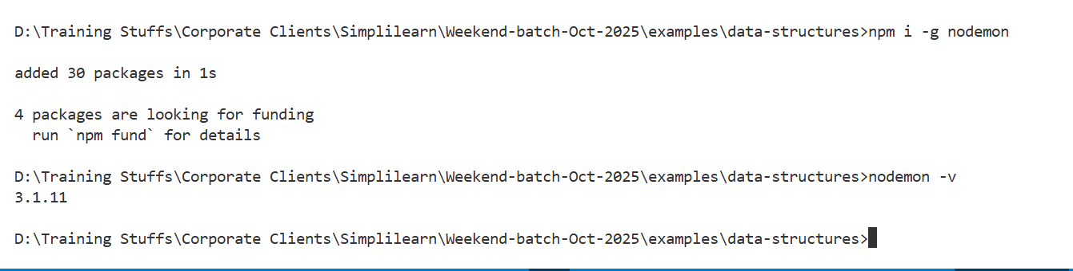

Set: It is a built-in datastructure available in Javascript that maintains only unique elements, it provides methods to manage the elements in the set
Built in methods of Set
- add() : It is to add an element you pass to the Set
- delete() : It removes an element you pass from the Set
- clear(): It removes all the elements
- has(): It checks if the element is present or not in the Set
- size: It is property to check the size of the Set, how many elements are present.

How to create Set?
let names = new Set();
names.add(“Lenovo”);
names.add(“Apple”);
names.add(“HP”);
names.add(“Dell”);
names.add(“Apple”); // it doesn’t add Apple because it is already present.
console.log(names.has(“HP”)) ; // true if present else false
names.delete(“Dell”); // deletes the element Dell
set-demo.js
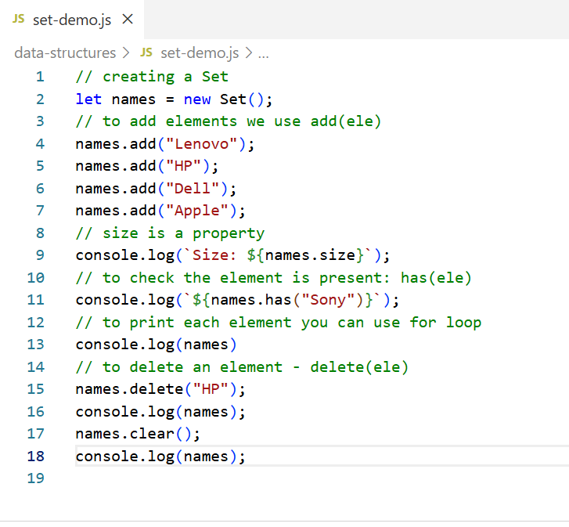
Output:
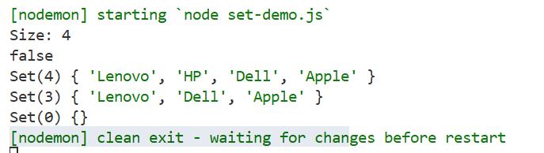
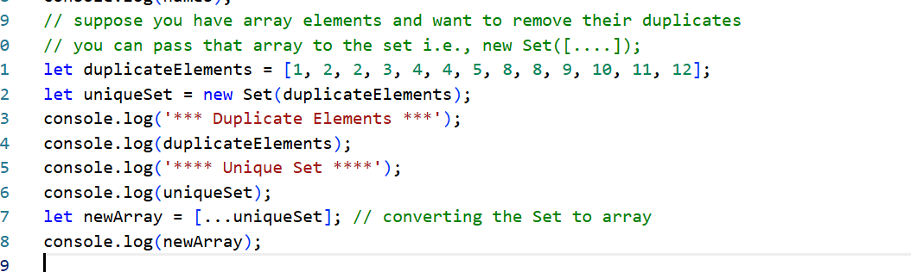

Map:
It is another type of collection that can maintain data in key & value pair, it supports only unique keys however value can be duplicate, below are the methods
- set(key, value) : Add / Update
- get(key): Read
- has(key): Check if the key is present
- delete(key): To delete
- clear(): To delete all
- size: Count
let employeeMap = new Map();
employeeMap.set(1, { id: 1, name : “Alex” });
employeeMap.set(2, {id : 2, name : “Bruce”});
employeeMap.get(1); // returns the value associated with the key 1
employeeMap.delete(1); // deletes the key & value
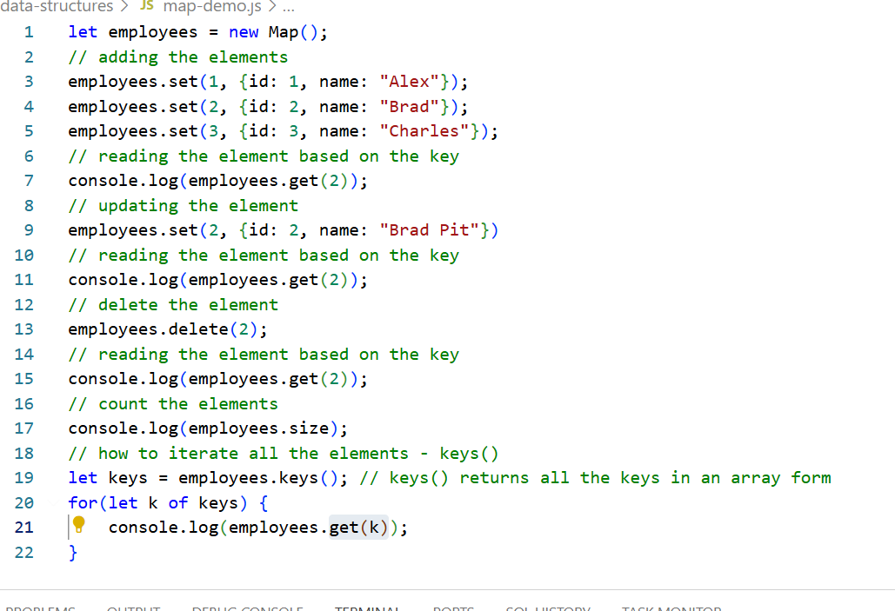
Arrays: In Javascript array can store elements in sequential order, and it has many built in methods
- forEach: to iterate
- map: to transform into another array
- includes: to check if the element is present or not
- push: adds element at the end
- unshift: adds element at the beginning
- pop(): removes from the end
- shift(): removes from the beginning
- slice(): to get a subarray
- filter(): to get an array that matches to the filter/condition
- reduce(): combines into one value - reduces an array into anything like number, object
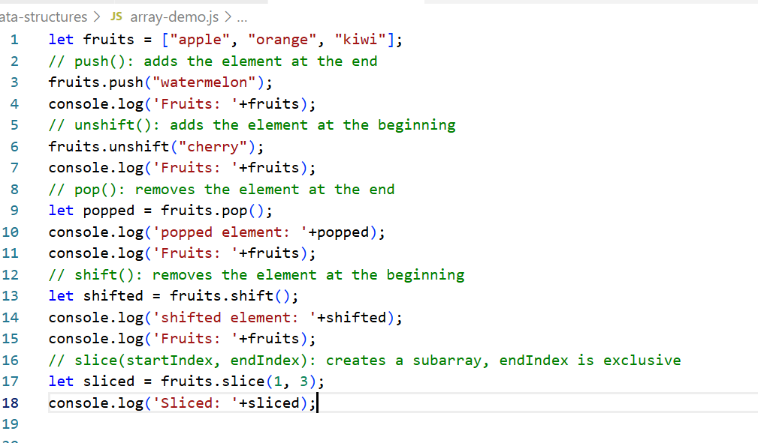
Output:
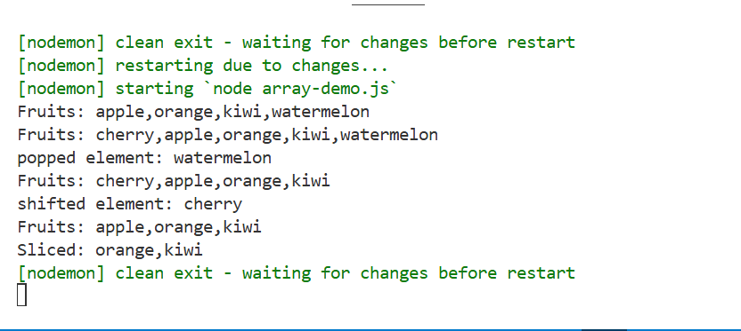

filter(callbackFn): This is used to create a new array by filtering the elements based on the condition
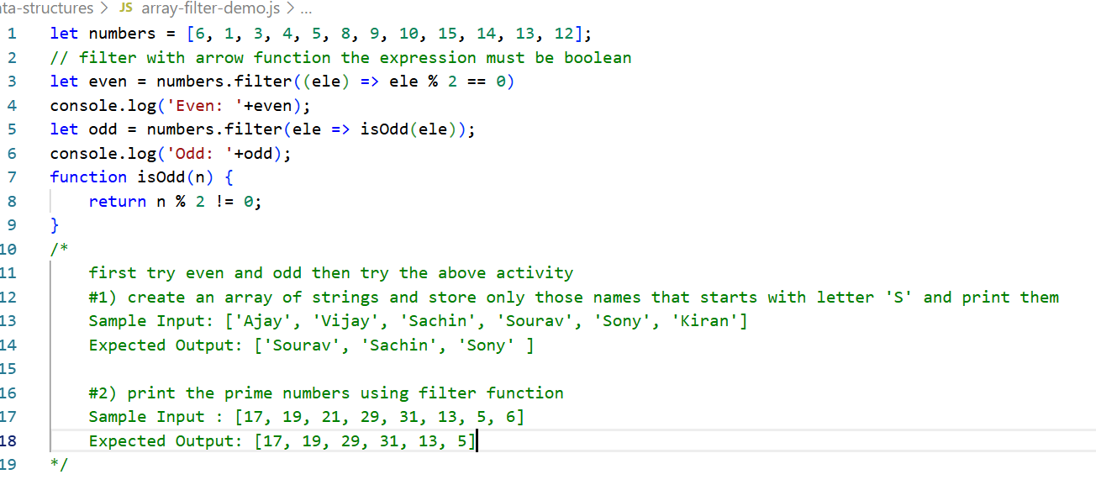
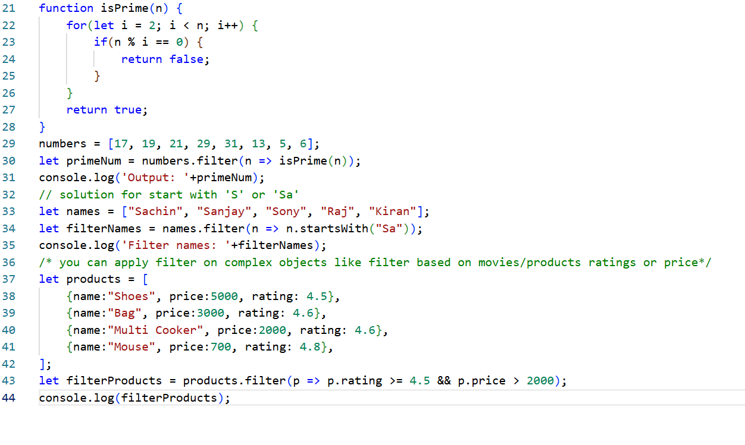
Output:
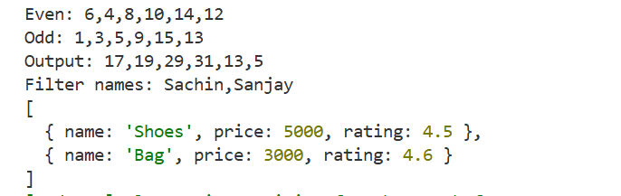
You can also sort the array
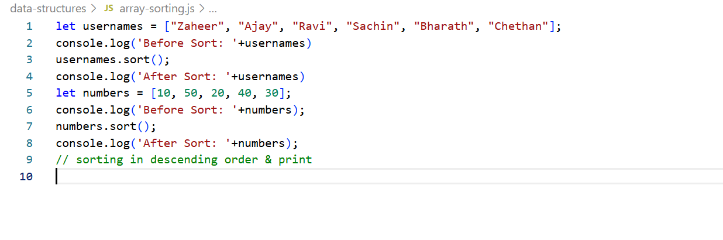
Output:
